*Program 1 :*

*Write a C program to read 10 values from a text file and perform mathematical operations including addition, subtraction, multiplication and Division. And store the output in a seperate text file.*

#include <stdio.h>

#include <stdlib.h>

*void* sort(*int* arr*[]*,*int* n,*int* ascending)

{

    for(*int* i=0;i<n-1;i++)

    {

        for(*int* j=0;j<n-i-1;j++)

        if (ascending && arr[j]>arr[j+1])

        {

*int* temp=arr[j];

            arr[j]=arr[j+1];

            arr[j+1]=temp;

        }

        else if(!ascending && arr[j]<arr[j+1])

        {

*int* temp=arr[j];

            arr[j]=arr[j+1];

            arr[j+1]=temp;

        }

    }

}

*int* main()

{

    FILE *inputFile;

*int* values[10];

    inputFile=fopen("input.csv","r+");

    if(inputFile==NULL)

    {

        printf("File not found\n");

        return 0;

    }

    for (*int* i=0;i<10;i++)

        fscanf(inputFile,"%d,",&values[i]);

    sort(values,10,1);

    fseek(inputFile,0,SEEK_END);

    fprintf(inputFile,"\nAscending: ");

    for (*int* i=0;i<10;i++)

        fprintf(inputFile,"%d,",values[i]);

    sort(values,10,0);

    fprintf(inputFile,"\nDescending: ");

    for (*int* i=0;i<10;i++)

        fprintf(inputFile,"%d,",values[i]);

    fclose(inputFile);

    return 0;

}

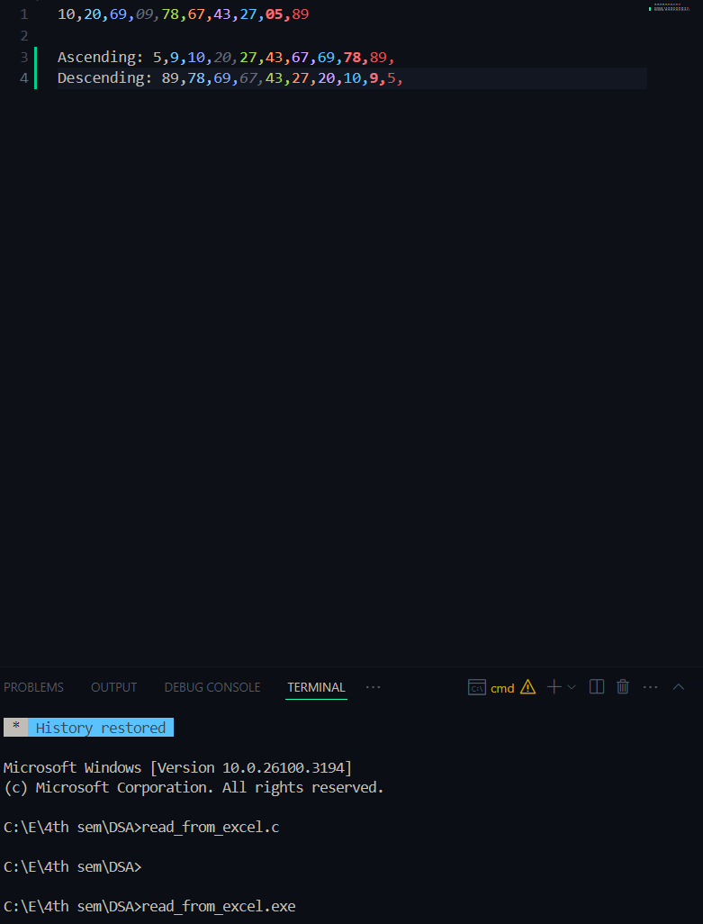

Write a C program to Search an element values in a excel file. Display whether the element is present or absent on the console window.

#include <stdio.h>

*int* main()

{

    FILE *inputFile;

*int* values[10];

*int* searchValue,is_found=0;

    inputFile=fopen("input.csv","r");

    if (inputFile==NULL)

    {

        printf("404:file not found\n");

        return 1;

    }

    printf("Value to find: ");

    scanf("%d", &searchValue);

    for (*int* i=0;i<10;i++)

    {

        fscanf(inputFile,"%d,",&values[i]);

        if(values[i]==searchValue)

        {

            is_found=1;

            break;

        }

    }

    if(is_found)

        printf("Element is present.\n");

    else

        printf("Element is absent.\n");

    fclose(inputFile);

    return 0;

}

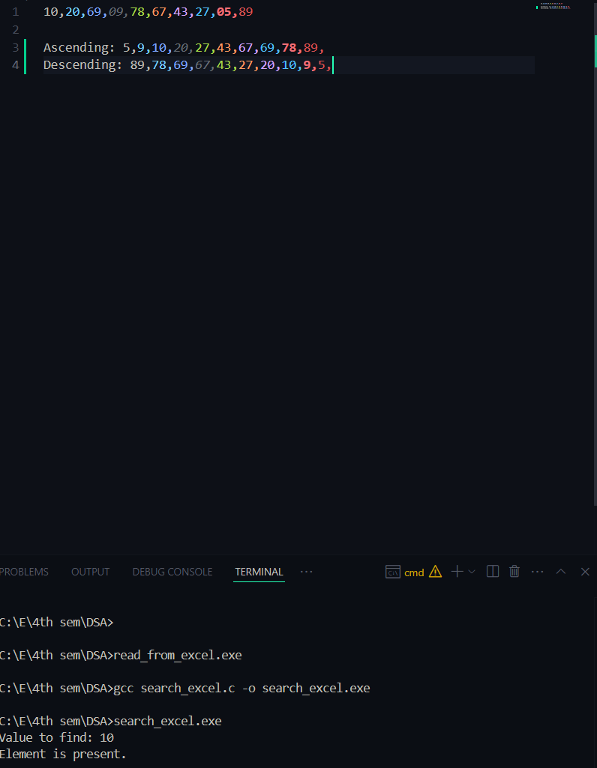

Write a c program to read 10 values from an excel file, Sort and store ascending values in the next column of excel file, store descending values in the next column of excel file.

#include <stdio.h>

#include <stdlib.h>

*void* sort(*int* arr*[]*,*int* n,*int* ascending)

{

    for(*int* i=0;i<n-1;i++)

    {

        for(*int* j=0;j<n-i-1;j++)

        if (ascending && arr[j]>arr[j+1])

        {

*int* temp=arr[j];

            arr[j]=arr[j+1];

            arr[j+1]=temp;

        }

        else if(!ascending && arr[j]<arr[j+1])

        {

*int* temp=arr[j];

            arr[j]=arr[j+1];

            arr[j+1]=temp;

        }

    }

}

*int* main()

{

    FILE *inputFile;

*int* values[10];

    inputFile=fopen("input.csv","r+");

    if(inputFile==NULL)

    {

        printf("File not found\n");

        return 0;

    }

    for (*int* i=0;i<10;i++)

        fscanf(inputFile,"%d,",&values[i]);

    sort(values,10,1);

    fseek(inputFile,0,SEEK_END);

    fprintf(inputFile,"\nAscending: ");

    for (*int* i=0;i<10;i++)

        fprintf(inputFile,"%d,",values[i]);

    sort(values,10,0);

    fprintf(inputFile,"\nDescending: ");

    for (*int* i=0;i<10;i++)

        fprintf(inputFile,"%d,",values[i]);

    fclose(inputFile);

    return 0;

}

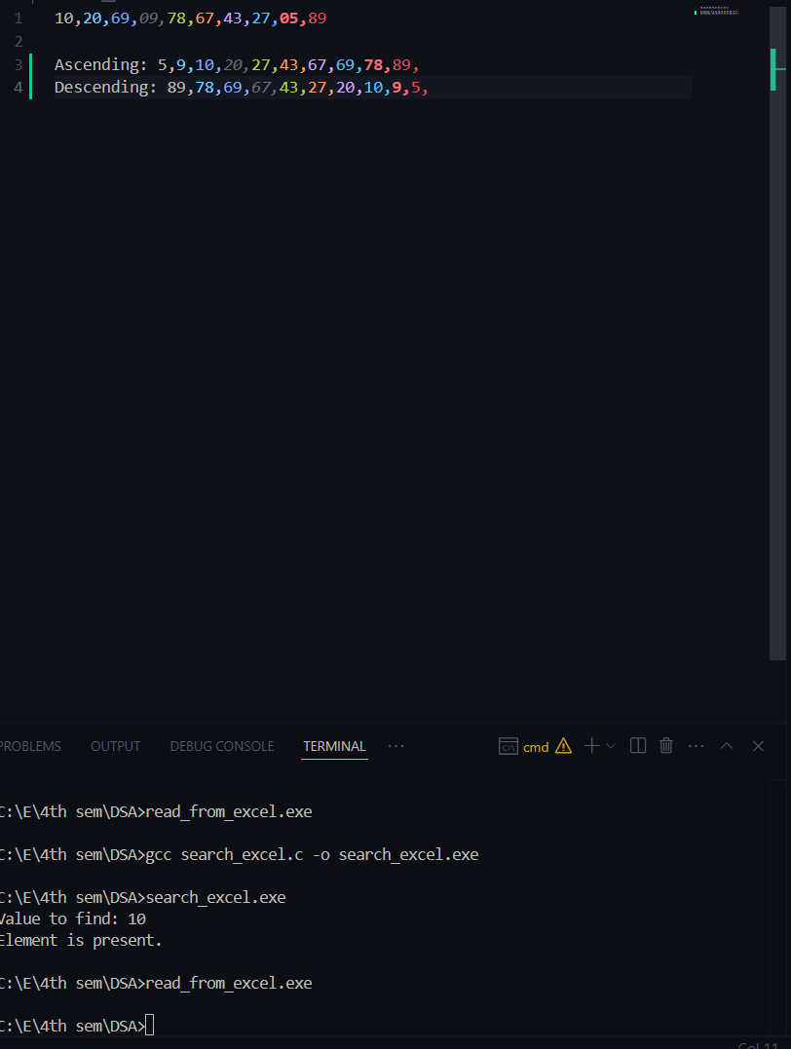

*//N random numbers between (P,Q)*

#include <stdio.h>

#include <stdlib.h>

#include<time.h>

*int* main()

{

    FILE *inputFile;

    inputFile=fopen("input.txt", "w");

    if (inputFile == NULL)

    {

        printf("File not found\n");

        return 1;

    }

*int* r,p,q,n;

    printf("enter the value of P, Q and N\n");

    scanf("%d%d%d",&p,&q,&n);

    srand(time(0));

    printf("%d random numbers between %d and %d are:\n",n,p,q);

    for(*int* i=0;i<n;i++)

    {

        r= p+rand()%(q-p+1);

        printf("%d\n",r);

        fprintf(inputFile, "%d ", r);

    }

    fclose(inputFile);

    printf("Press any key to close\n");

*char* a;

    scanf(" %c",&a);

    return 0;

}

